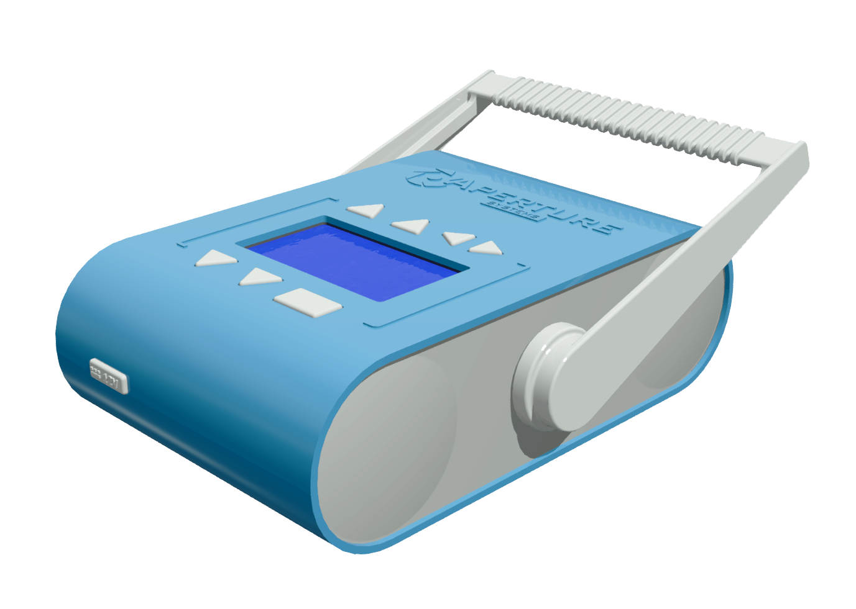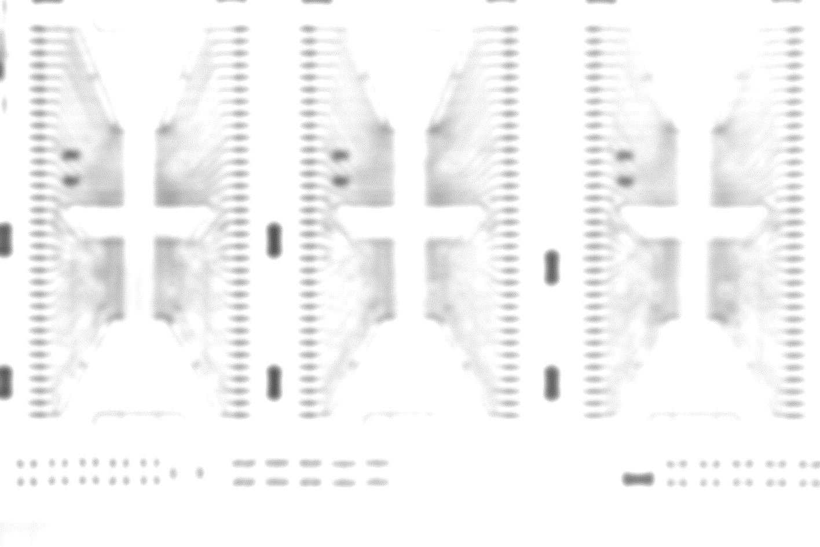



**AX100 – User Guide**

1. Unit Features.

2. Unit Description.

3. Brief introduction to radiography.

[ TOC GOES HERE ]

**Safety Notice:**

The Aperture AX100 produces ionizing radiation, which has the potential to cause cellular damage. When used responsibly the AX100 is a safe instrument, but by purchasing this unit it is understood that;

* The user assumes sole responsibility for safe operation of this x-ray source, as well as any state, local or provincial regulatory compliance.
* Aperture Systems, Inc. accepts no responsibility for any injury or danger to personnel due to ionizing radiation exposure, and / or any injury or damage due to misuse, improper servicing or tampering of this x-ray source.
* Aperture Systems, Inc. assumes no responsibility for any injury or damages caused by improper radiographic techniques or procedures.



Unit Features:

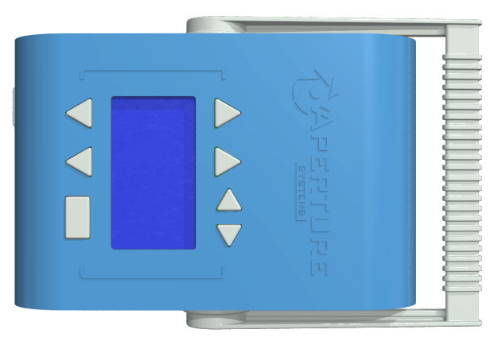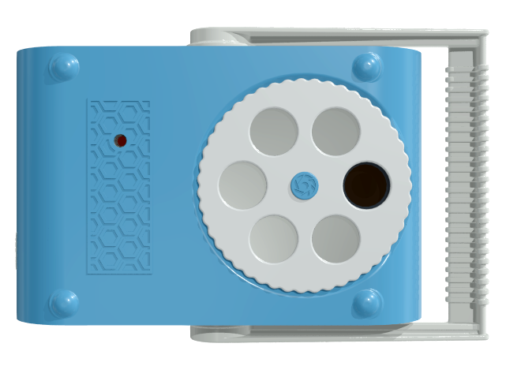

1. LCD Display

2. Main Menu Navigation

3. Sub-Menu Navigation

4. Increment Variable

5. Decrement Variable

6. On / Enter / Expose

7. 12V Power In

8. Handle

9. X-Ray Aperture

10. Filter Selector

11. Tripod Mount

Unit Features (continued):

1. **LCD Display:** Serves as the visual interface for the AX100, featuring a simply-navigable menu structure.
2. **Main Menu Navigation:** These buttons allow navigation of the main menu (kVp, mA, exposure, timer, system).
3. **Sub-Menu Navigation:** These buttons allow navigation of sub-menus, if existent.
4. **Increment Variable:** This button increments the setting/variable displayed on the current menu page.
5. **Decrement Variable:** This button decrements the setting/variable displayed on the current menu page.
6. **On / Enter / Expose:** This multifunction button turns on the machine, serves as “enter” where applicable, and when held, initiates the x-ray exposure sequence.
7. **12V Power In:** Accepts a 5.5mm x 2.5mm barrel for charging the x-ray unit.
8. **Handle:** This movable handle may be used to carry, or position the x-ray source.
9. **X-Ray Aperture:** Radiation exits the source here.
10. **Filter Selector:** This rotatable wheel allows filters of different thickness to be positioned in front of the x-ray source.
11. **Tripod Mount:** An ISO 1222:2010 standard (1/4-20 UNC thread) tripod mount.

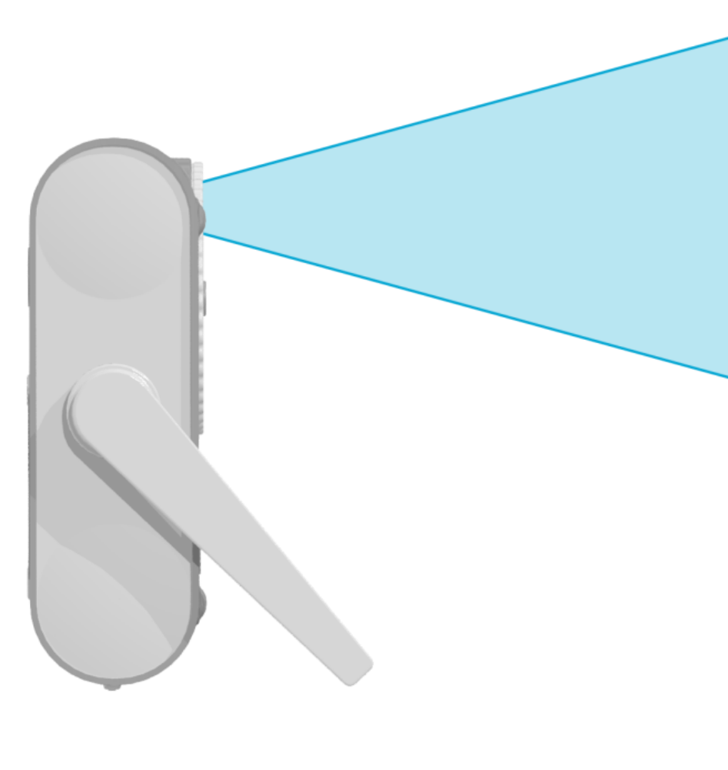

**Unit Description:**

The Aperture AX100 is a mobile x-ray machine designed to be an easily-operable source of x-ray illumination for industrial, analytical and artistic radiography. It has been engineered to provide a finely-focused point source of radiation for capturing fine detail in inanimate objects including but not limited to;

* Circuit boards, cable harnesses, ball-grid array ICs and other similar electrical fixtures.
* Mechanical connections, buried mating surfaces, threads & blind holes.
* Composite materials and molds.
* Non-destructive reverse engineering & test assemblies.
* Forensic and archeological artifacts.
* Questionable packages and / or items.
* Immobile objects and assemblies which cannot be reasonably taken from the field to a lab.

Other more obscure uses for the AX100 are possible, such as verification of radiation shielding integrity, calibration of radiation detection equipment and fine-art radiography.

Unit Description (continued):

The source is powered from an internal, maintenance-free lithium ion battery pack which may be charged from any 12V power supply, including but not limited to solar panels and automobile power outlets. A 12V switch-mode wall adapter is included with the AX100.

The AX100 may be operated as a stand-alone unit through its inbuilt LCD interface, or remotely though any Bluetooth enabled device that can run its associated software. Further, this Bluetooth API has been openly published to allow integration with custom, end-user developed applications.

The source features a variable-thickness high-pass filter for selectively attenuating lower energy x-rays which contribute little to the final exposure, and could otherwise damage sensitive electronic assemblies. For ease of positioning the AX100 features a rotatable handle, a standard tripod mount, and weighs no more than a typical consumer DSLR camera.

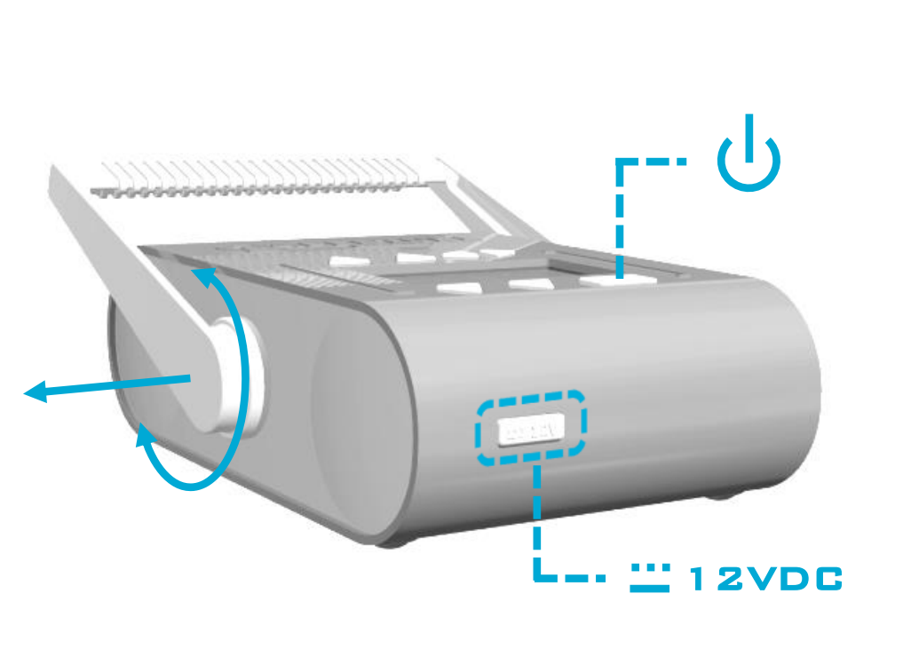

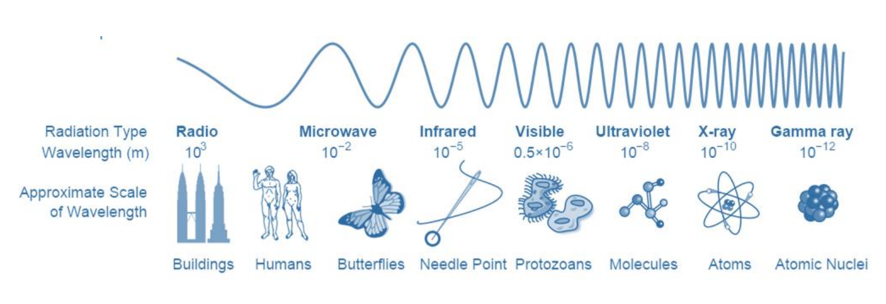

**Introduction to Radiography:**

X-rays are a form of electromagnetic radiation, much like radio waves, microwaves and the visible light emitted by many sources encountered in daily life. Unlike radio waves and visible light however, x-rays are a form of ionizing radiation –that is to say, their constituent photons carry a great deal of energy, and likewise, are able to deeply penetrate otherwise-opaque matter.

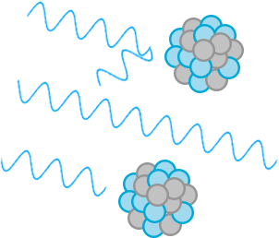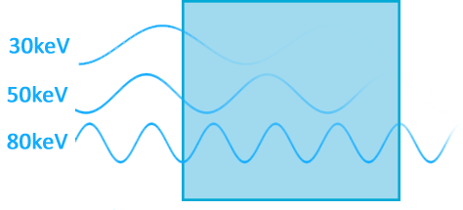

Introduction to Radiography (continued):

X-ray photons come to a halt when they interact with atomic nuclei. This is a very energetic process which has the potential to damage molecular bonds and form ions, hence the term, “**Ionizing Radiation**”.

Photons with higher energies have a smaller wavelength, and as such are statistically more likely to travel through objects without hindrance. Further, matter which is less dense is less likely to impede the path of x-ray photons. The combination of these two facts allows us to use x-rays to photograph the internals of opaque objects, as well as discriminate between the objects’ constituent materials. This process of x-ray photography is known as **radiography**.

The energy of an x-ray photon is typically measured in kilo-electronVolts. To provide a wide range of x-ray energies and thus the possibility for great image contrast, x-ray machines designed for radiography typically are broad-spectrum sources, with the maximum possible x-ray energy being a setting on the machine labeled **kilovolts‑Peak** or, “**kVp**”.

Increasing the value of this setting shifts the average emitted x-ray energy upward, and thus, allows for better imaging of denser objects. The kVp setting in practice, amounts to **radiographic contrast**.

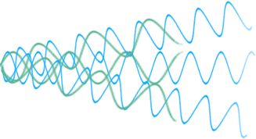

Al

To reduce the intensity of soft x-ray illumination it is common practice to add an aluminum discs in front of the x-ray source, with the thickness of such discs co-responding to their soft x-ray attenuation ability. This aluminum in effect, becomes a **high-pass filter** on the x-ray beam’s spectrum. Thicker aluminum filters more strongly attenuate the low-energy x-rays in the beam, than do thinner filters.

X-Ray Photon Energy (keV)

Intensity

Unfiltered, Ideal Beam

2mm Al

3mm Al

**Introduction to Radiography (continued):**

X-rays with high energy are historically, and colloquially known as “**hard**” x-rays, while x-rays with comparatively lower energy, and thus, comparatively lower penetrating power, are known as “**soft**” x-rays.

When recording x-ray images of dense objects, hard, high-energy x-rays are needed to effectively penetrate the subject. Unfortunately, this also means that there will be a great deal of soft x-rays bombarding the subject which do very little to add detail to the final image, and in fact, are needlessly detrimental to the molecular integrity of the subject.

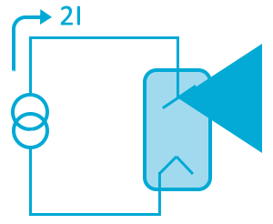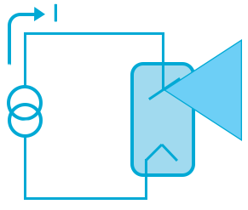

Flash Drive - 0.5 mAs

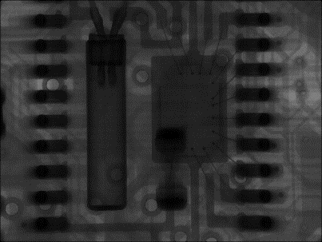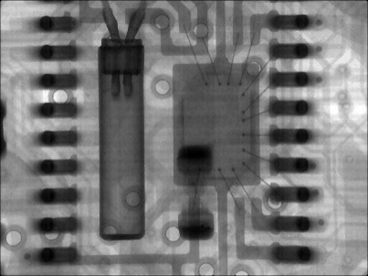

Flash Drive – 1.0 mAs

1 mAs

Introduction to Radiography (continued):

The intensity of the x-ray beam is a function of the volume of electrons flowing through the source’s x-ray tube. The magnitude of this current directly dictates the beam’s intensity, with greater currents corresponding to a more luminous x-ray source. Typically this current is also an adjustment on the x-ray machine, and is colloquially known as “**mA**” (milliAmperes).

The duration for which the x-ray source is kept luminous is the last major adjustment on an x-ray source, with the setting aptly named “**exposure time**”. The combination of exposure time and beam luminosity is known as “**mAs**” (milliAmpere‑seconds), and it is this which dictates the overall exposure of a radiograph.

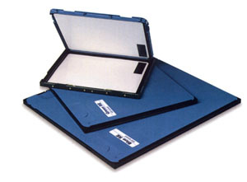

*Indirect capture, with Film and Intensifying Cassette*

Halide film itself is not extensively responsive to x-ray illumination, but its sensitivity may be enhanced through use of an intensifying cassette. Such a cassette contains a rare-earth phosphor screen which absorbs the x-ray radiation and re-emits the energy as visible light.

Use of an x-ray cassette greatly reduces the amount of radiation required to record an x-ray image, but does so at the expense of image detail and resolution.

*Direct capture, with Paper Film*

Standard silver-halide enlargement paper is responsive to x-rays and may be used to capture x-ray images directly. In practice such films capture the highest-resolution x-ray images at a rather small expense, but long exposure times are required as such film is poorly sensitive to x-radiation.

Silver-Halide enlargement paper may be purchased from Ilford Photo, and may be processed in a darkened room with Kodak D-76 Developer & Rapid Fixer. Red LED light is safe for working illumination.

Introduction to Radiography (continued):

X-rays cannot be focused in the same way normal light can, and so, all forms of transmission radiography are **shadowgraph** techniques. Recording these shadowgraphs may be accomplished by a number of methods, with each means having a unique mix of benefits and costs.

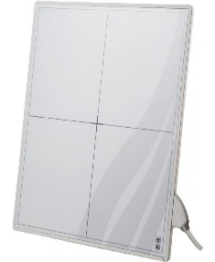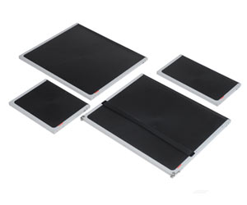

*Direct capture, with a CMOS Sensor Array*

It is possible to capture x-ray images directly by laminating a phosphor screen atop a CMOS image sensor of the type found in digital cameras. With this technique it becomes comparatively simple to capture x-ray photos, but due to the cost associated with photolithography such CMOS sensors are quite expensive.

*Indirect capture, with an image plate and Scanner*

It is possible to capture x-ray images indirectly by first exposing a metastable phosphor plate, and thereafter scanning the plate with a laser to stimulate emission of the latent image. Such “image plate” systems are a form of semi-digital radiography, and are common place in modern medical practice.

Introduction to Radiography (continued):

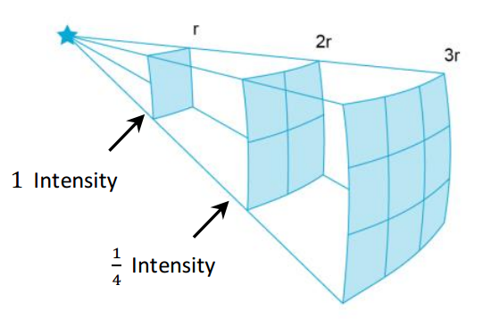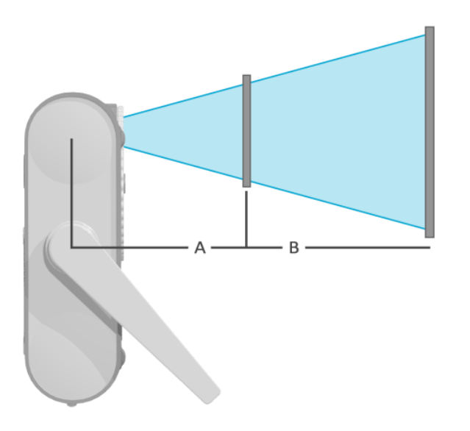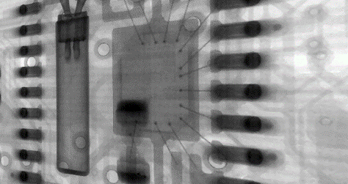

Note also, that if the subject is not positioned parallel to the image detector, there will be trapezoidal, or other geometric distortion in the captured radiograph.

Introduction to Radiography (continued):

As radiography is a shadowgraph process, the degree to which a subject’s detail is magnified is a function of (A) how far the subject is from the x-ray source, and (B) how far the x-ray detector is placed from the subject. Greater magnifications can be achieved by either reducing distance A, or increasing distance B.

A typical x-ray beam may be modeled as a point source, with its intensity diminishing as $\frac{1}{r^{2}}$. Thus, a radiograph taken at twice a distance must be irradiated four times longer to maintain the same exposure.

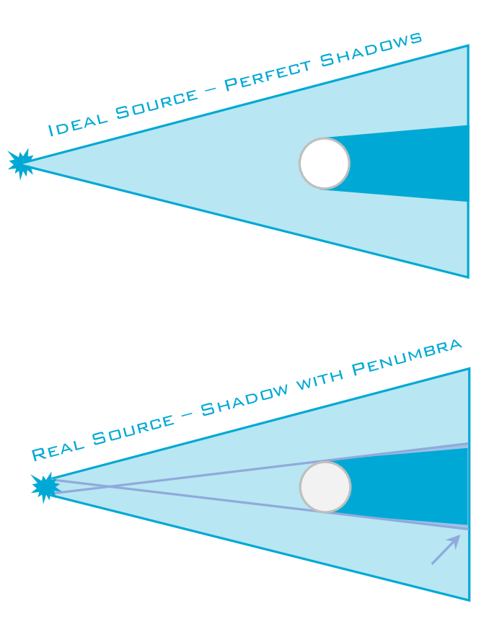

0.25mm Focal Spot

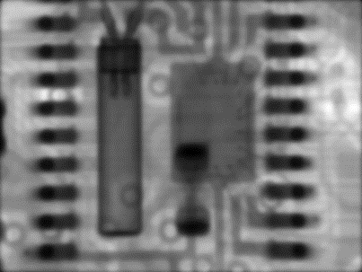

2mm Focal Spot

Introduction to Radiography (continued):

A radiograph’s spatial resolution (detail) is influenced by the size of the x-ray source used for illumination. Perfect shadows are cast in theory, if the x-ray source is infinitesimally small. In practice however this is not the case, and real, macroscopic x-ray sources do induce **penumbra distortion** in the captured shadowgraphs.

For this reason, a source’s **focal spot size** is typically made a known detail about the machine, with smaller sources granting more resolving power to the radiographer than larger ones.

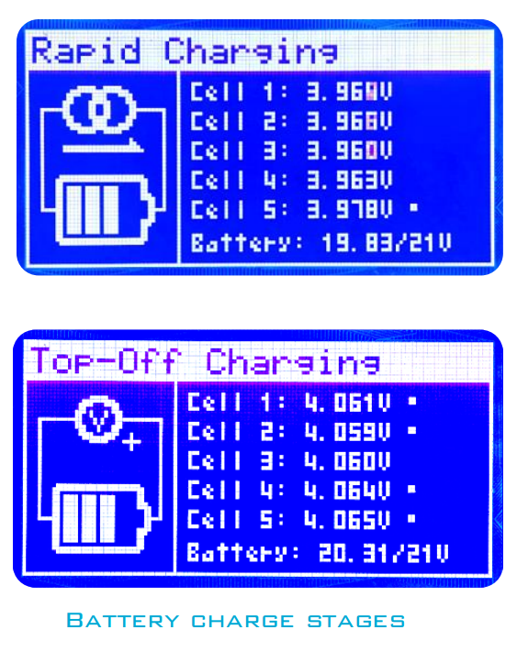

**Charging the Unit:**

Prior to initial use, it is good practice to ensure that the unit is fully charged. To do so, simply apply 12V power to the AX100 by inserting an appropriate barrel jack. If off, the unit will automatically boot up and enter its charge cycle. It will remain in this state until the battery is fully charged, where thereafter the source will enter trickle charge mode to ensure a proper battery voltage is maintained.

Removing the power source terminates the charge cycle and brings the unit into its normal operational state, if the battery voltage is sufficient. If the battery is fully depleted, the unit will indicate so, and promptly power off.

The AX100 may be charged from any 12V power source capable of supplying at least 3.5 amperes. It accepts a 5.5mm x 2.5mm, center positive barrel jack, [eg: switchcraft #760].

***Note:***

*Inserting a barrel jack supplying the incorrect voltage or polarity may damage the x-ray source!*

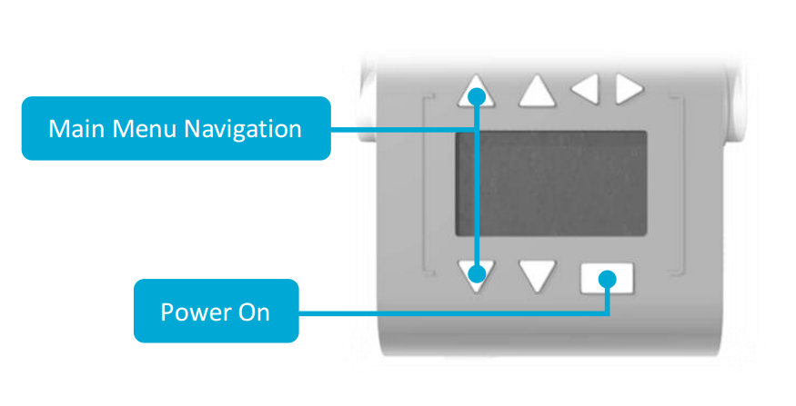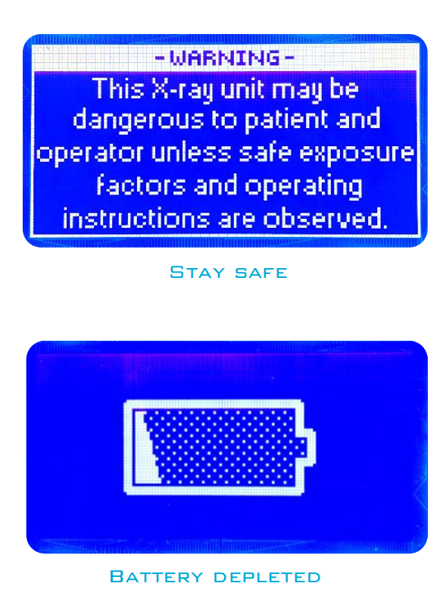

**Using the AX100:**

Preparing the AX100 for an x-ray exposure is rather simple.

If not already done, first power on the unit by holding down the “on” button. The AX100 will boot, display an FDA-mandated safety warning, and afterward display its home-screen. If the unit’s battery is depleted, a *dead battery* icon will flash and the AX100 will immediately power off.

The home screen menu is navigable using the leftmost arrow buttons, and contains four main menu selections; **kVp**, **mAs**, **timer** and **system**.

To adjust the peak kilovoltage, navigate to the kVp page using the main menu navigation buttons. On that page, it is possible to adjust the kVp variable with the increment / decrement buttons in steps of 1keV.

To set the tube current, use the main menu buttons to navigate to the **mA** page and adjust that variable likewise. This variable may be adjusted in steps of 100µA (100 microamperes).

Using the AX100 (continued):

After 5 minutes of inactivity, the unit will automatically power off. To immediately turn off the unit, hold the “main-menu down” button for more than 4 seconds.

A countdown timer is provided on the **timer** page for introducing delay before an exposure, to allow the operator to distance themselves from the x-ray source. This variable may be adjusted in steps of 1 second using the increment / decrement buttons.

As the x-ray tube requires a short amount of time to prepare for an exposure, this timer may not be shorter than 3 seconds.

Using the AX100 (continued):

To set the exposure duration, navigate to the **expos.** page and modify that variable using the increment / decrement buttons. This variable may be adjusted in steps of 100ms (100 milliseconds).

To initiate exposure, hold down the “on/enter/expose” button until the unit responds accordingly. The exposure sequence begins with a countdown of the predetermined duration, and x-rays are emanated at the end of this sequence.

It is possible to prematurely terminate this sequence by briefly pressing the “on/enter/expose” button once more.

During irradiation an audible signal is generated, which ceases after the exposure is complete. After exposure, the unit returns to its home screen.

Page 1 displays the status of the unit’s Bluetooth connectivity. The device is discoverable as “Aperture AX100”, and may be paired with any device which supports Bluetooth 2.0. When connected, it enumerates using the SPP (serial-port-profile) and may be remotely controlled via a simple API.

**System Pages:**

The system pages display various information about the AX100, and are accessible at the bottom of the main menu. It is possible to navigate these pages via the **sub-menu navigation buttons**, which are located in the top-right corner of the unit’s user-interface.

Page 3 displays general information about the AX100 unit.

Page 2 displays the status of the system’s lithium ion battery. Each cell’s voltage is stated, as well as an overall battery state of charge meter.

**Troubleshooting:**

blargh

**Maintenance:**

The AX100 requires no regular maintenance, however, the device should be kept clean and free of dirt for a long service life. It is safe to clean the x-ray source using damp cloth and surfactant, but to maintain the integrity of the unit’s plastic shell *solvents must not be used to clean the AX100*!

The unit’s handle may be removed by rotating it perpendicular to the bottom of the AX100, and pulling both hubs outward to the extent necessary to free the plastic retaining keys from their slots.

The following components are user-replaceable:

AX100 Handle (AP-AX100-001)

12V DC Power Supply (AP-AX100-002)

Please contact Aperture Systems if either part is required.

**Service:**

It is recommended that if in the unlikely circumstance that service is required for the AX100, the unit be returned to its manufacturer for proper repair. If such repair is required, please contact Aperture for a Return Material Authorization (RMA) number and shipping instructions to return the product appropriately. Items returned without an RMA number are not guaranteed to be appropriately processed.

No responsibility will be assumed by Aperture Systems for goods damaged during shipping, so it is recommended that shipping insurance be purchased from your chosen freight carrier. We recommend using either UPS or FEDEX freight services when returning this product.

Damaged or faulty units must be properly disposed of according to local and federal regulatory requirements, or returned to Aperture Systems for proper recycling. The AX100 contains lead shielding and lithium metal, so be respectful of the environment and do not improperly dispose of the AX100 or any part thereto related.

While Aperture Systems does not financially support modification or “hacking” of our products, we make no attempt to obscure our system’s internal design. Please note, that any end-user modification to our units immediately voids any provided warranty.

**Tube Thermal Characteristics:**

As required by U.S. CFR Title 21, §1020.30

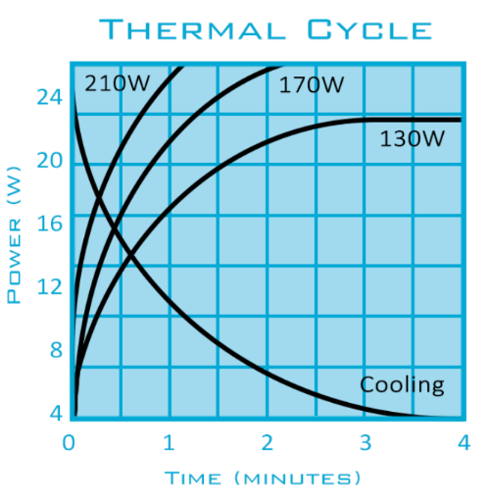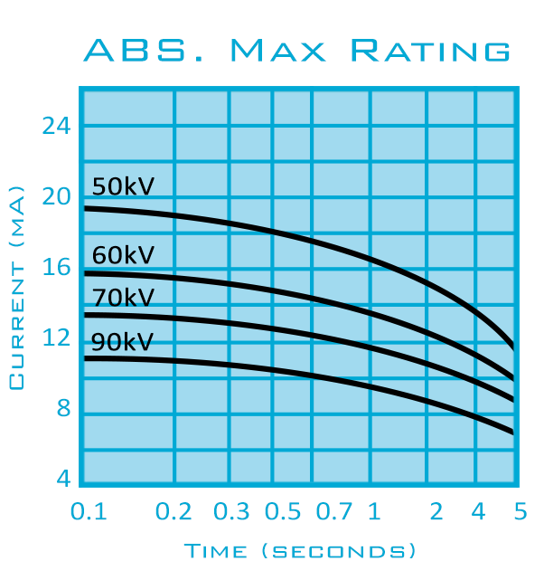

**Detailed Tech Specs:**

|  |  |  |  |  |  |
| --- | --- | --- | --- | --- | --- |
| X-Ray Energy | 40 - 80 | keV | Battery Type | Panasonic Lithium Ion | - |
| X-Ray Current | 100 - 1500 | µA | Input Voltage | 12 | V |
| Target Material | Tungsten | - | Input Current | 3.5 | A |
| Target Angle | 12 | ° (deg) | Power Receptacle | 5.5 x 2.5 mm Barrel, Pin + | - |
| Focal Spot Diameter | 0.25 | mm | Weight | ~ TBD ~ | kg |
| Aluminum Filtration | 0.5 – 3.5 | mm | Bounding Box | 24 x 4.5 x 9.5 | cm |
| Anode Thermal Mass | 7 | kJ | Shell Material | ABS Plastic | - |
| Maximum Duty Cycle | 1 : 5 | - | ROHS | Exempt | - |
| Bluetooth™ System | v2.0, Class 2 | - | Operating Temp | 0 - 40 | ° C |
| Bluetooth™ Name | “Aperture AX100” | - | Relative Humidity | 20 - 80 (non-condensing) | % |
| Tripod Mount | 1/4-20 UNC / ISO 1222:2010 | in |  |  |  |
| Battery Capacity | 70 | WH |  |  |  |